Topic: Computer Networks

Lesson 1: Network Basics

|  |  |
| --- | --- |
| Aim | 0b •ectives |
| Master communication skills and competences in the network basics, types of networks and networking technologies | At the end of this lesson, students will be able to:   * describe networks and their main features * list the difference between PAN, LAN, MAN, WAN * state network topology, network channels, protocols * discuss and present findings in pairs and small groups * write a summary based on different media |

# I. Lead-in

l. Match the computing devices in the box with the pictures below.

|  |
| --- |
| terminal; cash-point (ATM); fitness tracker; self-service checkout; |

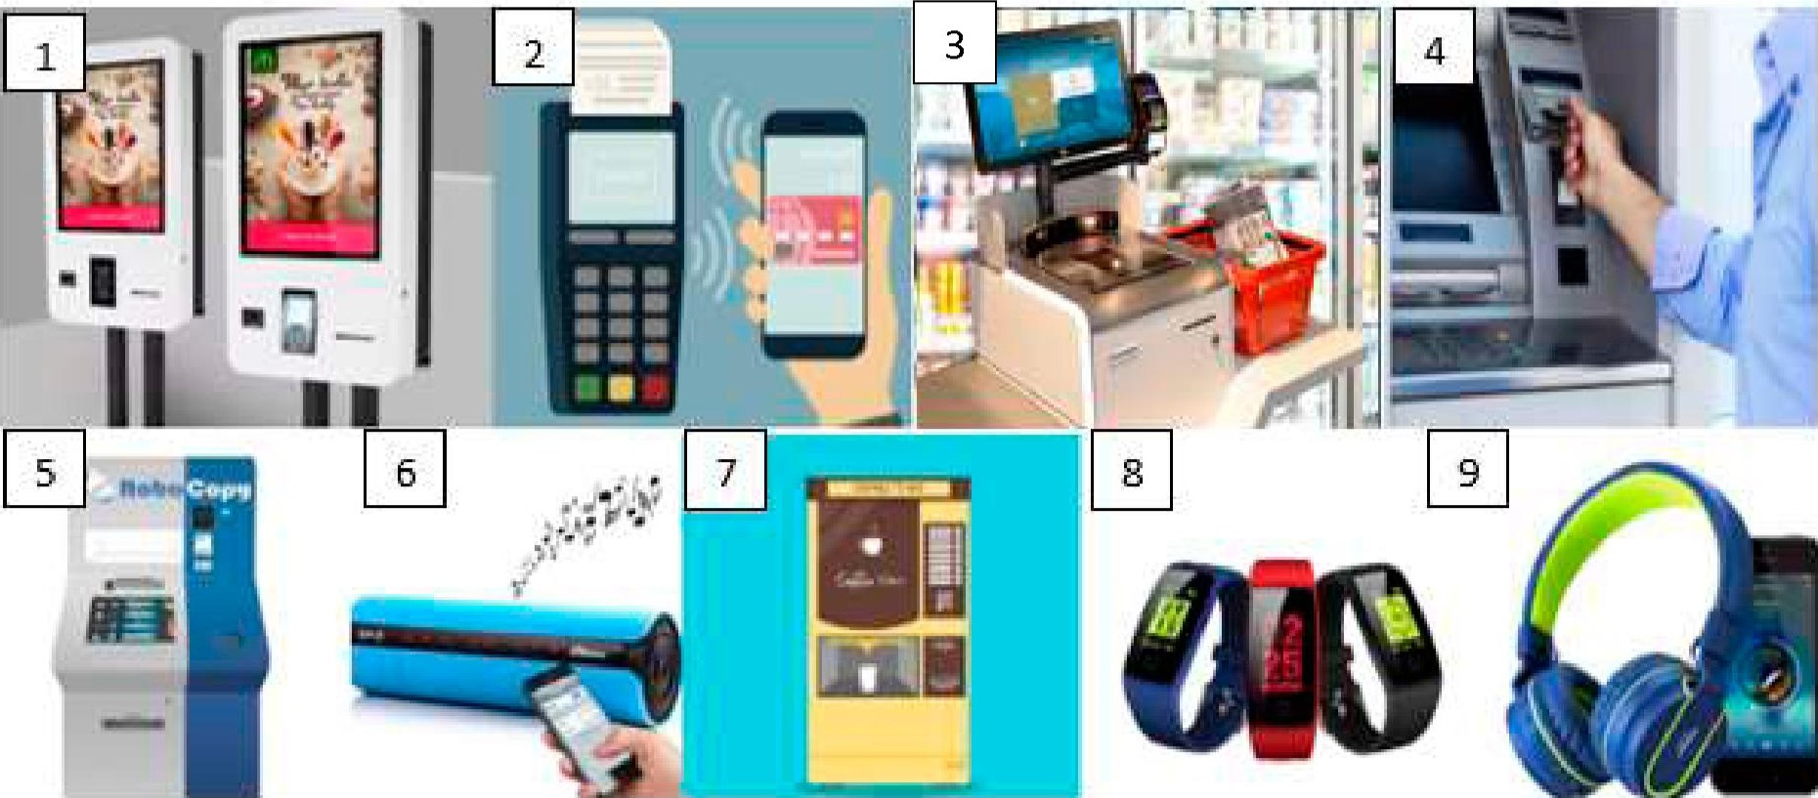

2. In today's world it is highly impossible to perform daily tasks and communicate without a computer network. Share your opinion on the questions.

a) What computing devices do you use on a regular Wire thin metal thread basis? Address Task 1 if necessary.

with a layer of plastic b) Do you think they are on a network? Is it wired or wireless? around it, used for carrying

c) What are the benefits of using networks for electric current people, businesses?

# Il. Vocabulary Focus

l. Do the quiz to find out what you know on the topic of computer networks. Work in groups of three or four people.

|  |  |
| --- | --- |
| 1. A computer network is . computers connected together | 1. two or more 2. three or more c four or more |
| 2. This network typically consists of two or more local area networks, covering a large geographical area | 1. LAN 2. WAN c Intranet |
| 3. This type of network does not have a dedicated server; all the computers are independent | 1. peer-to-peer 2. client-server c metro olitan area network |
| 4. On this network topology, all devices are connected to the same circuit, forming a continuous loo | 1. star 2. ring c bus |
| 5. Before sending data over a network it is divided into small chunks named | 1. packets 2. blocks c acka es |
| 6. The language used by computers to communicate with each other on the Internet is called | 1. Ethernet 2. ADSL c TCP/IP |
| 7. What cables are used to transfer information to the Internet over long distances at high speed? | 1. copper cables 2. Ethernet cables 3. fibre-optic cables |
| 8. What device allows several computers on a local network to share an Internet connection? | 1. an ADSL port 2. a router 3. an Ethernet ort |
| 9. What device serves as a common connection point for devices in a wireless network? | 1. wireless access point 2. wired router c wireless ada ter |
| 10. Bluetooth is a wireless technology that uses radio waves to transmit data over . | 1. long distances 2. medium-range distances 3. short distances |

1. Look at the diagram below illustrating the essence of a typical network. Consider the questions using the key verbs in the box. Work with a groupmate. Present your ideas to the group.
   * 1. How does a network link devices together?
     2. How does a signal travel along a communication channel?

route; convert; transmit; carry; pass; forward; broadcast; flow; interface

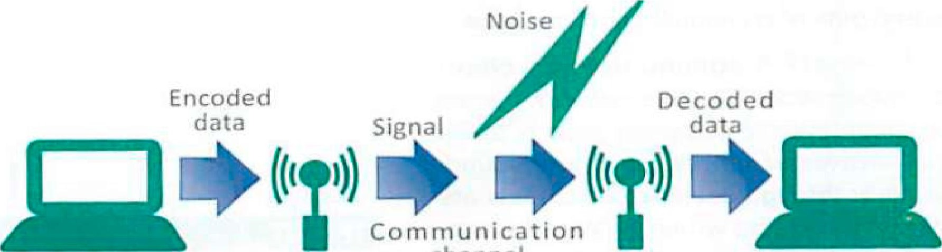

channel

Source Transmitter Receiver Destination

1. Networks can be classified according 10 [heir size and geographic scope. Look al lhe abbreviations and complete lhe statements below with one oflhefour network types.

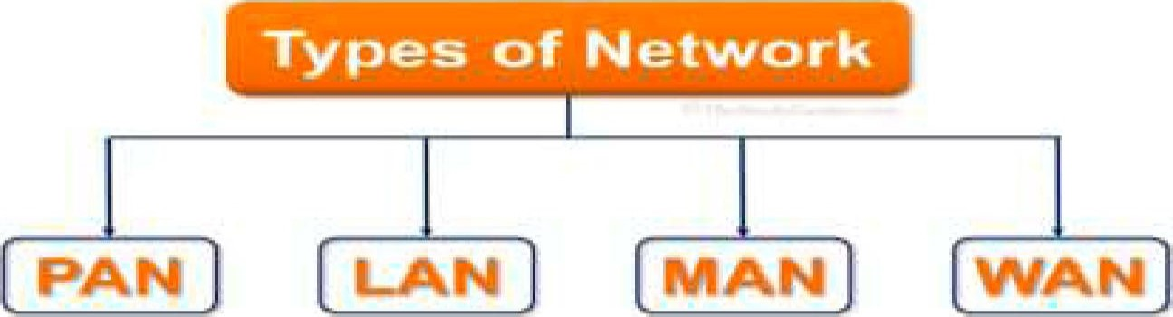

1.connects smart devices or consumer electronics within a range of 10 meters and without the use of wires or cables.

2.are data communication networks that connect personal computers within a very limited geographical area — usually a single building.

* + 1. covers a campus or a town and is widely used in cable television networks available in the whole city.
    2. Schools, colleges, university computer labs and home networks are examples of

5.covers a large geographical area and usually consists of several smaller networks, which might use different computer platforms and network technologies.

* + 1. Wi-Fi networks that you can access in airports, coffee shops, and other public places are



* + 1. could be used to sync data from a handheld device to a desktop computer, ship data wirelessly to a printer, or transmit data from a smartphone to a wireless headset.
    2. The Internet is the world's largest



1. Complete the sentences about networking basics with the words and word combinations in the box.

Ethernet cables; Bluetooth networks; Wi-Fi•, WANs•, fibre-optic; cellular networks; cable; Internet

* + 1. In a basic network, computers are connected by aallowing file sharing.
    2.  cover large geographic areas, like a country or even multiple countries.
    3. They are built by large telecommunication companies. The largest WAN in existence is the
    4. In many homes, are used to connect computers.
    5. Phone or cable TV lines then connect the home LAN to the ISP. Much of the Internet uses high-speedcables to send data over long distances.

6.is the standard technology for building wireless LANs and public hotspots.

* + 1. allow handhelds, mobile phones and other devices to communicate over short distances.
    2.  are used in mobile phone communications.

1. Match the network devices on the left with the descriptions.

|  |  |
| --- | --- |
| 1. Hub 2. Switch 3. Router 4. Modem 5. Bridge 6. Repeater 7. Wireless access point (WAP)  1. Node | 1. connects two similar networks. 2. is a device that controls the flow of data within a network and also acts as a gateway to pass data from one network to another; it is used to direct traffic over major Internet trunk lines. 3. sends signals to individual nodes rather than broadcasting to all of them. 4. allows wireless devices to connect to a wired network. 5. extends the range of a network by restoring signals to maximum strength and retransmitting them. 6. extends a wired network by adding more ports. 7. contains circuitry that converts the data-carrying signals from a digital device to signals that can travel over various communication channels. 8. any device in a network |

1. The arrangement ofdevices in a network is referred to as its physical topology. Label the basic types ofnetwork topology below with the terms in the box. Then complete the statements with the appropriate types.

full mesh; point-to-point; star; bus; partial mesh



1.2. 3. 4. 5.



* + 1. When peripheral devices connect to a host device using expansion ports, USB cables or Bluetooth, these connections are an example oftopology.
    2. A network arranged as atopology features a central connection point for all workstations and peripherals. The central connection point is not necessarily a server. More typically it is a network device called a hub.

topology uses a common backbone to connect all network devices. The backbone functions as a shared communication link, which carries network data. topology connects each network device to many other network devices. Data travelling on a mesh network can take any of several possible paths from its source to its destinations.

5. In a  topology, some of the devices are connected to many devices together, but other devices are connected only to one or two devices.

1. Read frequently asked questions (FAQs) about networks below and underline the words and word combinations that give you a view on the following concepts.



# FAQs About Networks

What is a communication channel? A communication channel is the medium used to transport information from one network device to another. Data transmitted over a communication channel usually takes the form of an electromagnetic signal waves of light, electricity or sound. These waves can travel through the air or through cables, so channels are divided into two general classifications: wired and wireless. Wired channels transport data through wires and cables including twisted pair wires used for telephone land lines, coaxial cables for cable television networks and fibreoptic cables used for high-capacity trunk lines that provide main routes for telephone, cable and Internet communications. Wireless channels transport data from one device to another without the use of cables or wires.

What is a network protocol? This is the language or set of rules, that computers use to communicate with each other. Networks use different protocols. For instance, the Intemet uses TCP/IP. Protocols set standards for encoding and decoding data, guiding data to its destination, and reducing the effects of interference. Networks use more than one protocol, and the collection of protocols for a network is referred to as a protocol stack.

What is network architecture? In a client-server network, a computer acts as a server and stores and distributes information to the other nodes or clients. In a peerto-peer network, all the computers have the same capabilities — that is, share files and peripherals without requiring a separate server computer.

What is wireless networking? Wireless networks, however, use electromagnetic waves, such as radio waves and microwaves, to transmit data. Most wireless connections transport data as RF (radio frequency) signals. These are the main types of wireless networks:

* Satellites — for long distances;
* WiMAX for connecting Wi-Fi hotspots;
* Wi-Fi — for medium-range distances; - Bluetooth for short distances; - GSM for mobile phones.

Ethemet a system for

connecting computers into networks

Which is better: a wired or wireless LAN? Wired LANs are more difficult to install, but they are cheaper, faster and more reliable. Wireless networks let you move or roam, from one access point to another, but they are less secure and subject to interference.

8. Perform the following tasks in groups of three orfour people.

l. Give two examples ofPANs, LANs and WANs.

1. Name the main types of wireless networks.
2. Consider the advantages of wired networks.
3. Explain when it is better to use a wired/wireless connection.
4. State five types of network topology. Compare and contrast the two of them.
5. Present four tasks that are handled by communication protocols.
6. Check the signal strength of a wireless connection on your device.

## Ill. Language Box

l. Watch the video "What Is a Network? " [50] and decide if the following statements are true orfalse. Correct the false ones.

1. A network is a group of connected computers.
2. There are three basic components that make up a network.
3. Network devices are referred to as nodes or hosts.
4. Network media (cable or wireless media) connect the devices together.
5. Network interface is used to connect the protocol to the medium.
6. Network protocol is a set of rules used by the people to communicate.
7. Watch the video again and complete the sentences with the missing words.
   1. A network is a group of devices that are connected in such a manner that they can 1) information and 2) with each other.
   2. To create a network, we must have a number of basic components such as network 3) network media, network 4) and the network protocol.



* 1. When we talk about network devices, we may just think about a group of computers connected together, but the network can also include other items such printers, game consoles, mobile phones, etc. Generally speaking, we call these devices nodes or 6)
  2. The network devices must be connected to each other in some way. The connection can be in the form of 7)  communicating through electrical signals, fiber-optic cables communicating through 8)  or wireless connection using 9) The cables or signals used to connect the host to the network refer to as the network 10)
  3. As there are different types of network media the network host should be equipped with an appropriate 11) in order to make the connection.
  4. The fttnction of the network interface card is to 12) the digital signals from the device into a signal that is suitable to be 13)through the network medium.
  5. A protocol is an agreed set of rules on how information is 14) and sent onto the network. The protocol provides the rules of 15)between the hosts.

1. Share your opinion on the questions with a groupmate.
   1. What is a network?
   2. What are the basic components of a network?
   3. What do nodes/hosts refer to on a network?
   4. What are the types of network media?
   5. What is a network interface used for?
   6. What is a protocol?
2. Watch the video "What Is the Cloud? " [58] and decide which ideas in the box are mentioned in it. Explain how they are related to the concept of "cloud computing '

virtualisation; servers; cloud vendors; Internet; virtual machine; Gmail;

Dropbox; databases; hybrid cloud; software; data centre; operating system; private cloud; Google Drive; infrastructure

1. Watch the video again and choose the correct statements.

1.

* 1. The term "cloud" refers to data centres that are accessed over the Internet.
  2. The term "cloud" applies to servers that are accessed over the Internet. 2.
  3. Cloud servers are placed in data centres all over the world.
  4. Cloud servers are tracked down in data centres all over the world. 3.
  5. Businesses and users do not have to administer physical servers and launch software applications on their own machines thanks to cloud computing.
  6. Businesses and users are to administer physical servers and launch software applications on their own machines due to cloud computing. 4.

a) The cloud enables users to manage computing and storage servers in a data centre instead of locally on the user device. b) In the cloud the computing and storage is implemented on servers in a data centre instead of locally on the user device. 5.

* 1. Gmail users can't access their emails and files via any Internet-connected device.
  2. Gmail users can retrieve their emails and files via any Internet-connected device.

1. Read the abstract "How Does Cloud Computing Work? " and consider thefollowing key ideas afterwards. Work with a groupmate.

|  |  |  |
| --- | --- | --- |
|  | |  | | --- | | Cloud Server | |

How Does Cloud Computing Work?

Cloud computing is possible because of a technology called virtualisation. Virtualisation allows for the creation of a simulated, digital-only "virtual" computer that behaves as if it were a physical computer with its own hardware. The technical term for such a computer is virtual machine. When properly implemented, virtual machines on the same host machine are sandboxed from one another, so they do not interact with each other at all, and the files and applications from one virtual machine are not visible to the other virtual machines, even though they are on the same physical machine. Virtual machines also make more efficient use of the hardware hosting them. By running many virtual machines at once, one server can run many virtual "servers", and a data center becomes like a whole host of data centers, able to serve many organisations. Thus, cloud providers can offer the use of their servers to far more customers at once than they would be able to otherwise, and they can do so at a low cost. Even if individual servers go down, cloud servers in general should be always online and always available. Cloud vendors generally back up their services on multiple machines and across multiple regions.

1. Think of 2-3 questions related to the text "How Does Cloud Computing Work? " in Task 6 and address them to your groupmates. Discuss the questions in groups ofthree orfour people.
2. Share your opinion on the ideas with a groupmate.
   1. Networking technologies have changed the way people work and communicate.
   2. Networks are an indispensable part of our lives. When there are outages, things go haywire. When there are slowdowns, we get frustrated.
   3. Although the cloud offers apps, storage and connectivity, keeping some of your data local offers security that is not available at remote sites.
   4. One of the ways we invite trouble into our digital lives is by careless file sharing.
   5. Social networks are a foe.

IV. Decision Bank

l. Look at the diagram illustrating a local area network. Match the features (A—F) of a network based on a centralised router with the descriptions (1—6) below.

To an ISP and Internet

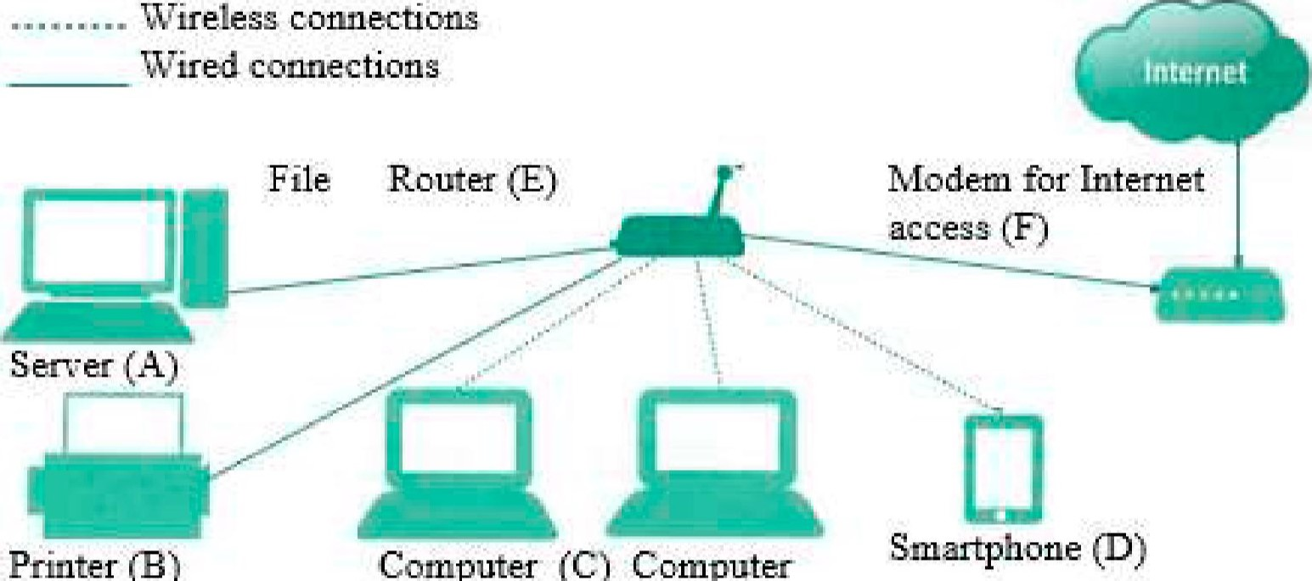

Wifeless

connections

Printer

(B)

Computer

(C)

Computer

l. Connect a printer to a wired or wireless connection so that all devices on the network can access it.

1. All the devices in your LAN can access the Internet if you connect the router to a modem supplied by an ISP.
2. Connect computers wirelessly, so you can use them in various rooms.
3. Connect a computer to a wired connection for maximum speed. Use it for online games or as a file server where you store and back up your data.
4. The router is the centrepiece of your network. Most wireless routers support five wired devices and a maximum of 255 wireless devices.
5. Connect your smartphone and you'll be able to use the LAN's Internet connection instead of your expensive data plan.
6. Do the following self-assessment task and complete the sentences below with the target vocabulary ofthis lesson.
   1. Networks can be classified as PANS, MANs and WANs.
   2. A communicationis the medium used to transport information from one network device to another.
   3. There are two types of channels — wired and



* 1. The Internet uses high-speedcables to send data over long distances.



* 1. A networkis a set of rules that computers use to communicate with each other. network, a computer acts as a server and stores and distributes information to the other nodes or clients.
  2. Networks can be configured in various such as star, mesh or bus.
  3. Any device in a network is referred to as a



* 1. Therefers to servers that are accessed over the Internet, and the software and databases that run on those servers.
  2. Cloud servers are located inall over the world.



1. Study the diagrams and get ready to illustrate how these networks operate using the prompts. Work in groups of three orfour people.

|  |  |
| --- | --- |
| 1. DSL Connection | * a DSL modem * convert computer signals into * high-frequency data signals * voice signals data signals * travel over telephone lines * telephone company Md'iiching station * roule 10 the regular telephone system * roule 10 the Inlernel |
| 2. Satellite Service | * dala from a customer 's computer (l) * convert inio signals by * the customer 's modem (2) * carried by cables to * a personal satellite dish (3) * broadcast to a communication satellite (4) * rebroadcast to a groundbased ISP (5)   -forward to the Internet (6) |
| 3. Mobile Network    Voice and Text  Messages | * cell networks * transmit voice and data * use radio signals   -flow to a cellular radio tower (l)   * transmitters and receivers * cover a specific area * use a unique frequency * pass to ground stations (2)   -forward to the Internet (3)   * route to a circuit-switched nemork (4) |
| 4. Wi-Fi Hotspot  Coffee shop Coffee shop  Intemet con nection wireless router Coffee shop customers | * a wireless local area network * operated by a business offer Internet access io the public * Internet connection * a device called an access point * broadcast Wi-Fi signals * within a range of a building * any device with Wi-Fi capability * detect the signal |

1. Divide into two teams andprepare a quiz about networking basics that includesfive challenging questions. Make sure you know the answers. Then take turns to ask and answer the questions to see which team scores the more.

## V. Conclusion Worksheet

Build and diagram the components and connections of a network. Choose one of the options or choose your own one and present it to the group. Use the ideas from this lesson and your background knowledge. Work in groups of three orfour people.

v/ home network v/ university network v/ bank network v/ hospital network v/ airport network v/ company network

## VI. Web Search

Explore the resources in the list to obtain additional information on network basics. Report yourfindings to the group.



https://www.techtarget.com/searchnetw https://www.softwaretestinghelp.co https://www.studytonight.com/com orking/definition/networking m/computer-networking-basics puter-networks/network-topologytypes

Ml. Revision Point

l. Read the abstract "Different Types of Cloud Deployments " and get ready to translate it into Belarusian or Russian. Use a dictionary, ifnecessary.

# Different Types of Cloud Deployments

There are five the most common cloud deployments. Private cloud is a server, data centre or distributed network wholly dedicated to one organisation. Public cloud is a service run by an external vendor that may include servers in one or multiple data centres. Unlike a private cloud, public clouds are shared by multiple organisations. Using virtual machines, individual servers may be shared by different companies, a situation that is called "Multitenancy" because multiple tenants are renting server space within the same server. Hybrid cloud deployments combine public and private clouds and may even include on-premises legacy servers. An organisation may use their private cloud for some services and their public cloud for others, or they may use the public cloud as backup for their private cloud. Multi-cloud is a type of cloud deployment that involves using multiple public clouds. In other words, an organisation with a multi-cloud deployment rents virtual servers and services from several external vendors — to continue the analogy used above, this is like leasing several adjacent plots of land from different landlords. Multi-cloud deployments can also be hybrid cloud and vice versa.

1. Complete the abstract about computer networks with the words in the box.

WAN; Internet; hardware; rotocols; cables; enable; LAN; exist

A computer network comprises two or more computers that are connected either by l) (wired) or Wi-Fi (wireless) with the purpose of transmitting, exchanging or sharing data and resources. You build a computer network using 2)(e.g. routers, switches, access points, and cables) and software (e.g. operating systems or business applications). Geographic location often defines a computer network. For example, a 3) connects computers in a defined physical space, like an office building, whereas a 4)can connect computers across continents. The 5)is the largest example of a WAN, connecting billions of computers worldwide. You can further define a computer network by the 6)it uses to communicate, the physical arrangement of its components, how it controls traffic and its purpose. Computer networks 7) communication for every business, entertainment, and research purpose. The Internet, online search, email, audio and video sharing, online commerce, live-streaming and social networks all 8)because of computer networks.



1. Do the quiz.

|  |  |
| --- | --- |
| 1. What type of network is a university that offers wireless Internet access to students and the local community operating? | 1. PAN 2. LAN 3. MAN 4. WAN |
| 2. Does data travelling on a wired channel tend to be more secure than data travelling on a wireless channel? | 1. Yes 2. No |
| 3. Which of the following situations is the most suitable for a network that connects most devices with cables? | 1. a university campus 2. a bank branch office 3. a private home d a coffee sho |
| 4. What type of wireless channels are most typically used for networks in homes and coffee shops? | 1. coaxial 2. microwave 3. WiMAX |
| 5. To extend the reach of your wireless network out onto your balcony, which of the following devices would be the best? | 1. hub 2. router 3. repeater   d atewa |
| 6. In the full mesh network how many possible paths are there between any two points? | d 10 |
| 7. What is cloud computing? | 1. It is a facility composed of networked computers, storage systems and computing infrastructure that organisations use to assemble, process, store large amounts of data. 2. System of storage that allows users to store private content on their hard-drives. 3. It is on-demand access, via the Internet, to computing resources hosted at a remote data centre managed by a cloud services provider. 4. The process of using computer technology to com lete a iven oal-oriented task |
| 8. Clouds computing deployment models can be . | 1. public 2. private 3. hybrid d all of the above |
| 9. Virtualisation enables cloud providers to make maximum use of their data centre resources | 1. True 2. False |

1. Get ready to speak on the topics below and assess your performance according to the following scale.

|  |  |  |
| --- | --- | --- |
| Comprehensive | Rather confident | Limited |

* + Definition of a network and its main characteristics.
  + Classification of networks based on size and scope.
  + Communication channels and their main types.
  + Network topology; network architecture.
  + Network protocols.  Cloud computing.

Lesson 2: Web and Internet Technology

|  |  |
| --- | --- |
| Aim | 0b •ectives |
| Master communication skills and competences in the Web and Intemet technology and their role in different spheres of people's life | At the end of this lesson, students will be able to:   * define the Internet and the Web and their basic features * explain the difference between the Internet and the Web * state the technologies and services of the Web * present and discuss findings in pairs and small groups * write a summ based on different media |

I. Lead-in

l. Share your opinion on [he quotes. Justify your point ofview.

|  |
| --- |
| Thé'nternet is so big, so powerful and pointless that for some people it is a complete substitute for life. |

The I

|  |
| --- |
| We are all now connected by the Internet, like neurons in a giant |

|  |
| --- |
| nternet gave us access to l thing; but it also gave rything access to us.  James |

e el

The internet could be a very positive step towards education, organisation and participation in a meaningful society

Noam Chomsky

2. Predict what questions ordinary users can ask about the Internet and the Web. Use the prompts below and make these questions. Then address them to your groupmate.

Intemet international Web a system for finding computer network that allows information on the Internet, in people to share information around which documents are connected to

the world other documents

to use the Internet; Internet connection; broadband access; mobile phone;

Wi-Fi; type of connection; online games; public access

## Il. Vocabulary Focus

l. Match the terms on the left with the definitions. Translate the words and word combinations in bold.

|  |  |
| --- | --- |
| l . Message   1. Latency 2. Email 3. Decryption 4. Hypertext 5. Twisted pair 6. Blog 7. Tag 8. Search engine 9. Bandwidth 10. Satellite 11. Microwave | 1. a particular word or some keywords which define how web browser will format and display the content of a web page. 2. an informational website displaying information in reverse chronological order; it is a platform where a writer shares their views on an individual subject. 3. the change of electronic signals that were stored in the form of a secret code back into a form that you understand. 4. a method of exchanging messages between people using electronic devices over the network. 5. a verbal, written or recorded communication sent to or left for a recipient who cannot be contacted directly. 6. the length of time that it takes for a computer to get a signal. 7. a document on a computer with built in links to other texts that the reader can access immediately. 8. a cable consisting of two wires twined round each other, used especially for telephone or computer applications. 9. an artificial body placed in orbit round the earth or moon in order to collect information or for communication. 10. a program that searches for and identifies items in a database, used especially for finding particular sites on the Web. 11. a range of frequencies within a given band, in particular that used for transmitting a signal, can be narrowband (dial-up) or broadband (DSL). 12. an electromagnetic wave with a wavelength in the range   0.001—0.3 m, shorter than that of a normal radio wave but longer than those of infrared radiation |

1. Match the words in Column A with the words in Column B to make collocations. More than one option can be possible. Then make statements using them.

|  |  |  |  |
| --- | --- | --- | --- |
| A. | online | B. | message |
|  | browse |  | the Internet |
|  | upload |  | a website |
|  | Internet |  | connection |
|  | hotspot |  | point |
|  | broadband |  | cable |
|  | surf |  | a web page |
|  | coaxial |  | service provider |

1. Read the sentences and choose the options from the ones given in italics to make true statements about the Internet.
   1. Once you are online, you can browse look up investigate the Web, visit chat rooms or send and receive emails.
   2. Fast Current Instant messaging can be a great way to communicate with friends.
   3. This software may not be fully suitable compatible adaptable with older operating system.
   4. Most webcams plug connect fill into a USB port.
   5. This highly addictive obsessive dependent game will keep you playing for hours.
   6. The technology allows data to be communicated/carried/lransmilled by mobile phones.
2. Match the types ofthe Internet protocols in the box with the definitions (1—10) below.

|  |  |
| --- | --- |
| TCP (Transmission Control Protocol)  UDP (User Datagram Protocol)  FTP (File Transfer Protocol)  SMTP (Simple Mail Transfer Protocol) IRC Internet Rela Chat | IP (Internet Protocol)  HTTP (Hypertext Transfer Protocol)  POP (Post Office Protocol)  VolP (Voice over Internet Protocol) Bit Torrent |

* 1. It transfers files between a local and remote host computer.
  2. It transmits text messages in real time between online users.
  3. It creates connections and exchanges packets of data.
  4. An alternative data transport to TCP used for DNS, Voice over IP and file sharing.
  5. It provides devices with unique addresses.
  6. It exchanges information over the Web.
  7. It transfers mail from an email server to a client Inbox.
  8. It transmits voice conversations over the Internet.
  9. It distributes files using scattered clients rather than a server.
  10. It transfers email messages from client computer to an email server.

1. Choose the odd one out in the word lines. Justify your choice.
   1. hypertext link webpage host
   2. coaxial bandwidth fibre-optic twisted pair
   3. POP IRC UDP
   4. browser server search engine
2. Look at the diagram with the target vocabulary of this lesson and match the terms related to the Web with the appropriate definitions below.

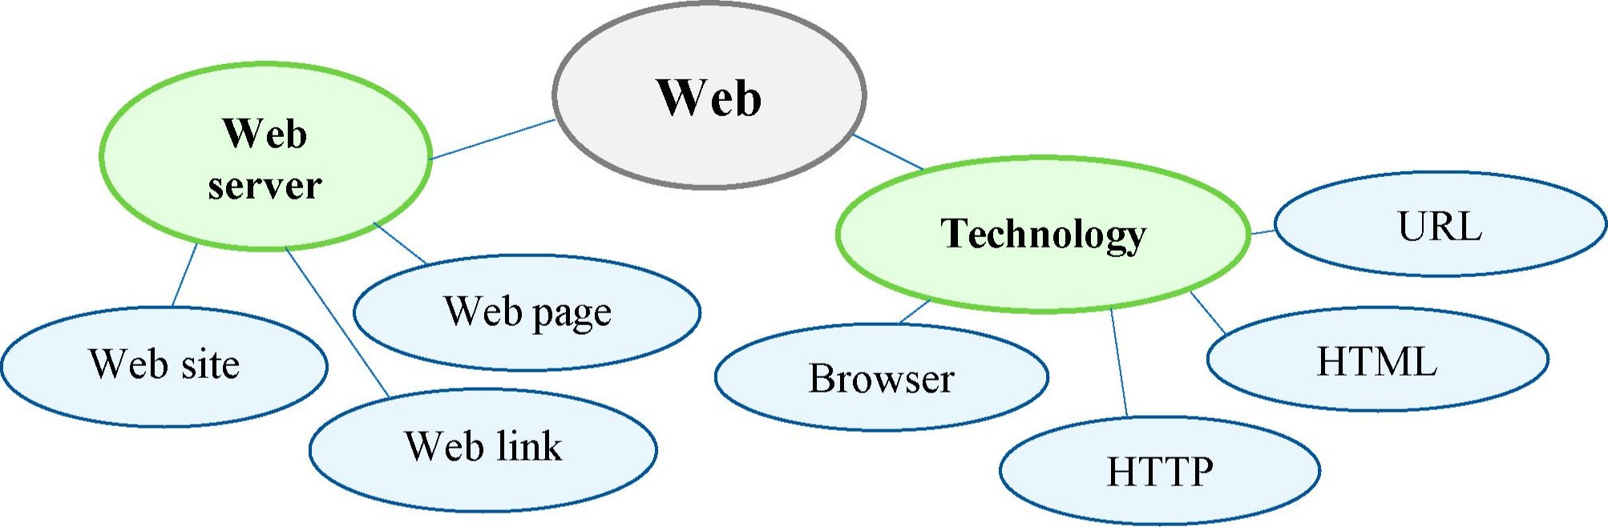

* 1. is a unique identifier for a web page.



* 1. is a set of connections between web pages.



* 1. is the software used to get and display web pages.



* 1. is a collection of HTML documents, images and sound files that can be



linked to each other and accessed over the Internet using a protocol called HTTP.

* 1. is a collection of web pages and related content that is identified by a



common domain name. They are organised and formatted, so it can be accessed using a browser.

* 1. is an Internet-based computer that stores website content and accepts requests from browsers.
  2. is a hypertext document provided by a website and displayed to a user in a web browser.
  3. is a standard protocol for communication between browsers and web



servers. It exchanges information over the Web.

* 1. is a set of elements for creating documents that a browser can display as a



web page.

1. Do the crossword and get the words related to the Internet technology.
   1. 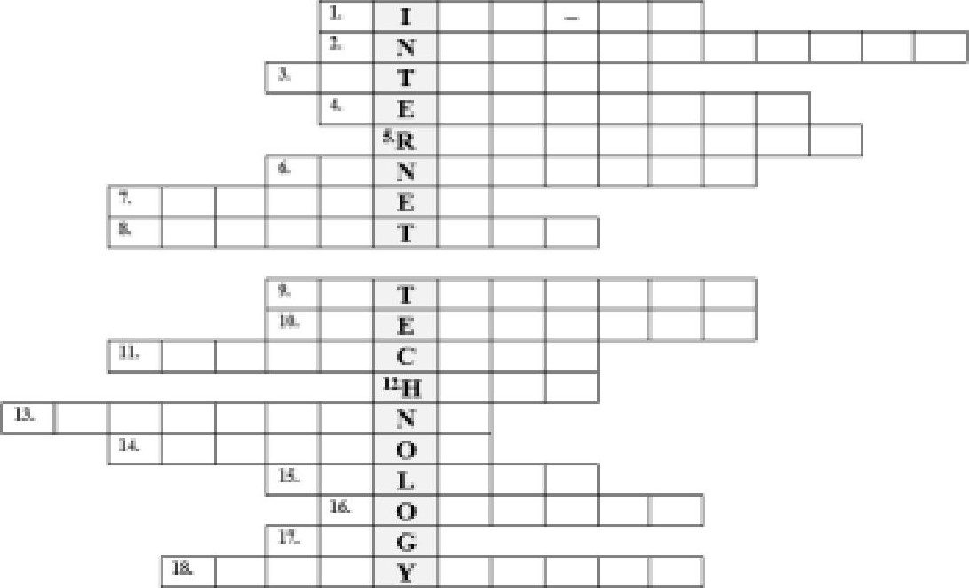Used remotely via a phone line.
   2. The act or process of blocking.
   3. A measure of delay.
   4. A person who receives sth.
   5. An electromagnetic wave with radio frequency.
   6. The maximum amount of data transmitted over an Internet connection in a given amount of time.
   7. A computer program with a graphical user interface for displaying and navigating between web pages.
   8. A text displayed on a computer display or other electronic devices with references.
   9. An artificial body that revolves around a planet.
   10. The rate at which sth occurs over a particular period of time.
   11. Transmit by radio or television.
   12. A computer that controls communications in a network or that administers a database.
   13. A connection from a hypertext document to another location activated by clicking on a highlighted word or image.
   14. A physical location where people can access the Internet typically using Wi-Fi.
   15. Transfer (data) from a smaller computer to a larger computer.
   16. A type of shielded and insulated copper cable that is used in computer networks to deliver cable TV services to end users.
   17. A set of characters constituting a formatted command for a Web page.
   18. A process that transforms encrypted information into its original format.
2. Explain the difference between the following concepts. Work with a groupmale.

l. The Internet and the Web.

* 1. Upload and download.
  2. Broadband access and narrowband access.
  3. Wi-Fi connection and cell connection.
  4. FTP and Bit Torrent.
  5. Web page and blog.
  6. Hypertext and text.

## Ill. Language Box

l. Do the quiz to find out how much you know on the topic of the Internet. More than one option can be correct. Work with a groupmate.

|  |  |
| --- | --- |
| 1. The Internet was | 1. invented in the mid-90s 2. popular in the 1960s c robabl created in the US |
| 2. To be connected to the Internet, it is necessary to have | 1. a computer 2. a modem 3. connection software |
| 3. Speaking about fast, high-bandwidth connection, we mean . | 1. broadband connection 2. dial-up connection c cable connection |
| 4. ADSL stands for | 1. Additional Digital Subscriber Line 2. Audial Digital Subscriber Line c As mmetric Di ital Subscriber Line |
| 5. The device that converts computer data into the form that can be transmitted over phone lines is . | 1. ADSL 2. a modulator/demodulator 3. a modem |
| 6. The standard protocol that allows a computer to communicate over the Internet is called | a) HTTP  c TCP |
| 7. The geographical region covered by one or several access points is called | 1. a wireless access point 2. a hotspot c a wireless network device |
| 8. The way(s) of wireless connection is(are) | 1. Wi-Fi 2. satellite c GSM |

2. Match lhe following Internet FAQs (1—10) with the answers (CIO) below and check your ideas in Task l.

l . How old is the Internet (the Net)? When was it created?

1. Who created the Internet?
2. Did the Internet become popular quickly?
3. How do you get online?
4. How fast are today's Internet connections?
5. How long has broadband existed?
6. How much does broadband access cost?
7. Why do you need a modem?
8. What does TCP/IP mean?
9. Are there other ways of accessing the Internet?

a)

Other methods include Wi-Fi, satellite, mobile phones and TV sets equipped with a modem. Wi-Fi enabled laptops allow you to connect to the Net if you are near a WAP, in locations called hotspot (parks, cafes or campus). Satellite services are used in places where terrestrial access is not available (on ships at sea). High end mobile phones provide access through the phone network.

b)

A modem (modulator/demodulator) converts digital signals into analogue ones so that data can be transmitted across the phone or cable network.

c)

Since the late 1990s.

d)

Today, ISPs offer a broadband, high-speed connection. The common types are cables offered by local cable TV companies and ADSL (Asymmetric Digital Subscriber Line), which work through phone lines. They are both faster than the traditional dial-up connection. Broadband access is also offered by some electricity networks.

e)

It took many years for the Internet to become popular around the world. It's only really since the mid-90s that the Internet has been a part of our daily lives.

# f)

It is hard to say exactly. The research that led to what we now know as the Internet began in the 1960s.

g)

Again, it is hard to say exactly who created it. The initial research was carried out by the Advanced Research Projects Agency in America, funded by the US government.

h)

To get connected, you need a computer, the right connection software and a modem connected to the phone line. You also need an account with an ISP, which acts as a gateway between your PC and the rest of the Net.

i)

The language used for data transfer on the Internet is known as TCP/IP (transmission control protocol/lnternet protocol). This is like the Internet operating system. Every computer connected to the Net is identified by a unique IP address.

j)

It depends on which company you choose. Nowadays some companies even offer free broadband.

1. Distribute the characteristics below between the four types ofInternet connections. One can match several types. Then watch the video "Connecting to the Internet "(from 0:01 till 1:26) [30] and check ifyou were right.

|  |  |  |  |  |  |  |
| --- | --- | --- | --- | --- | --- | --- |
| Dial-up |  | DSL |  | Cable |  | 3G/4G |

* 1. It uses your cable TV connection.
  2. It is much slower than other types.
  3. It is a wireless Internet connection.
  4. It may be the only option available in some areas.
  5. It plugs into your phone line.
  6. It is often used by smartphones.
  7. It is known as broadband Internet connection.
  8. It offers much faster speeds.

1. Watch the video (from 1:26 till the end) and mark the options (a e) as true orfalse.

You can buy Internet service from

* + 1. your cable company;
    2. a local technician;
    3. your phone company;
    4. an Internet Service Provider;
    5. shops around.

1. Restore the process of connecting to the Internet by matching the beginnings of the statements (1—10) with the appropriate endings (CIO). Watch the video (from 1:26 till [he end) again and check ifyou were right.

|  |  |
| --- | --- |
| l. Your ISP will guide you   1. They'll usually need to 2. Your ISP may also give you 3. You can also 4. Once you have everything set up, you can 5. If you want to connect several devices, you can 6. To do this, you'll need a wireless router, which takes 7. Your modem may already have a wireless router built-in, so you may not 9. To set up your wireless connection, follow   10. You should also turn on WPA or  WPA2 encryption and make sure you | 1. a modem and set it up for you. 2. need to buy one. 3. choose a strong password. 4. create a wireless home network. 5. the Internet connection from your modem and broadcasts it throughout your home. 6. through the entire process of connecting to the Internet. 7. buy a modem from a computer store and use the included instructions to set it up yourself. 8. the instructions included with your router. 9. send a technician to your home to turn on your connection. 10. open your Web browser and begin using the Internet |

1. To sum up the information you have just obtained, present your ideas according to the plan. Work in groups of three orfour people.
   1. The history of the Internet.
   2. The hardware for the connection to the Internet.
   3. The ways of connection to the Internet.
   4. The speed of the today's Internet.
   5. The main Internet protocols.

IV. Decision Bank

l. Name and list the key features of today's popular browsers in the pictures (1—5). Mingle with the groupmates to elicit their preferable web search options with the reasoning.

 1.2.3. 4. 5.

2. Look al the logos (a-I) oflhe most famous websites. How many do you recognise? Whal are lhey usedfor? Work with a groupmale.

1. d) g)  j)

|  |
| --- |
| MOVE |
|  |

LSi*NÉ

1.  h) k)

c)BitTorrent f)

l)

# ebay flickr

1. Share your ideas on thefollowing statements. Work in groups oftwo or three people.
   1. The Internet isn't just about email or the Web anymore.
   2. Thanks to new technologies people are getting together to take collective action like never before.
   3. E-commerce has become a practical reality for many people throughout the world.
   4. The Internet was initially used for contact with strangers, now it is a platform where people develop and cultivate their already existing relationships.
   5. The Internet is a phenomenon that has transformed life as we know it.
2. Complete the concept map and explain the difference between the Internet and the Web, their components andfeatures. Work in groups of three orfour people.

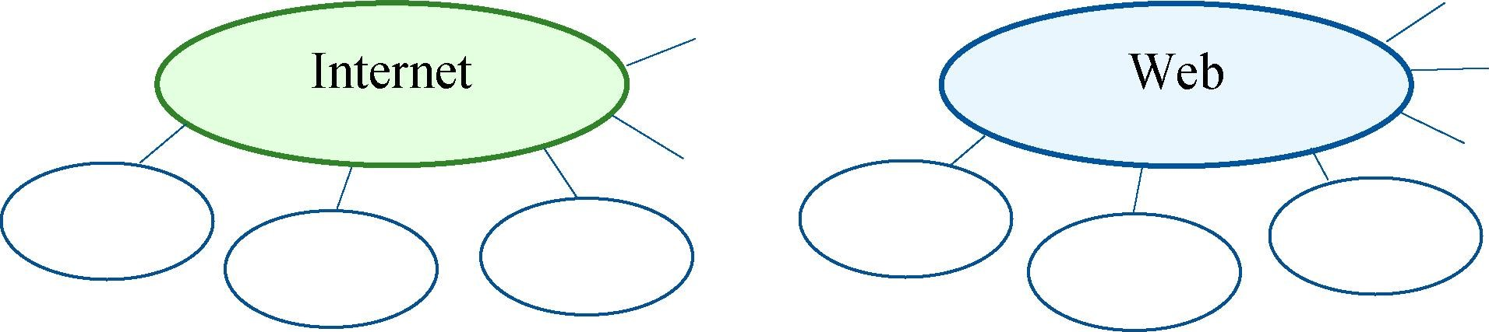

V. Conclusion Worksheet

Make a web page ofyour group. Consider its content, options ofpage navigation and

## some essential links. Name the URL ofyour page HOME SERVICE MENU CONTACT US and the parts of it, present the toolbar of the page

and recommend a browserfor afaster access to the STUDENT page. Work in groups of three orfour people. Community

## VI. Web Search

Explore the resources in the lisl 10 obtain additional information on Internet and Web technology. Report yourfindings 10 the group.



https ://www.geeksforgeeks.org/basics- https://www.ibm.com/cloud/learn/ https://www.geeksforgeeks.org/thecomputer-networking networking-a-complete-guide internet-and-the-web

## VII. Revision Point

l. Read the abstract "Network Features " and translate it into Belarusian or Russian. Use a dictionary ifnecessary.

## Network Features

ISPs control connection speeds based on the service plan you have selected. Your bandwidth cap is the top speed allowed by your plan. During peak times, ISPs can place further limits on speed, a process called bandwidth throttling.

When Internet upload speed differs from download speed, you have an asymmetric connection. When upload and download speeds are the same, you have a symmetric connection.

Most Internet connections are asymmetrical, with upload speeds considerably less than download speeds. Asymmetric connections discourage subscribers from setting up Web and email servers that would transmit lots of outgoing data.

Ping is utility software designed to measure responsiveness. Ping rate indicates how quickly data can reach a server and bounce back to you. Ping was named after the sound that a submarine's sonar makes when it bounces off an undersea object. Technically, Ping measures latency. Latency is the elapsed time for data to make a round trip from point A to point B and back to point A.

Speed and latency are not the only factors that affect your Internet experience. Jitter measures the variability of packet latency. Network traffic and interference can delay some packets and create erratic data flow.

1. Complete the abstract aboutfinding a Web page with the words in the box.

set of numbers; DNS server; path; request; URL; Web server; data ackets; link; IP address; router com uter; browser; Web a e

To find the Web page you want, you have to click on a Web page 1)or enter a(n) 2) a uniform resource locator into a browser. The URL is the address of the page. When you do that, the browser sends the URL to a(n) 3) The DNS server is the Domain Name Server. It uses a look-up table to find the 4)of the web server referred to in the URL. The IP address is a unique, 32-bit 5) Every computer on the Web has its own IP address. Once the DNS server has found the IP address, it sends it back to the browser. The browser then uses this IP address to send a(n) 6)to the Web server. The request is sent as a series of separate 7)which include both the IP address of the Web server and the IP address of the browser computer. These data packets are first sent to a(n) 8) which uses the IP address of the Web server to determine the best available route to each packet. The packets are passed from router to router until they reach the 9) They may travel by different routes before reaching the server.

As the individual packets reach the Web server, they're put back together again. The Web server now services the request by sending the requested 10)back to the browser computer. It travels as a series of separate data packets from router to router. This time the router uses the IP address of the browser computer to work out the best available 11)for each packet. As the packets arrive at the browser computer, they're combined to form the Web pages you requested and are displayed in your 12)



1. Match the beginnings of the statements (1—5) with the appropriate endings (a e).

|  |  |
| --- | --- |
| 1. The code behind most Web pages is 2. Tags are placed around pieces of text 3. A hyperlink is any clickable text, 4. You navigate through the Web using a program, 5. A text-based chat system (IRC) for instant messaging is designed | 1. to tell the Web browser how to display texts or pictures. 2. it is called a Web browser, which lets you search, view and print Web pages. 3. HTTvTL, which consists of commands called tags. 4. image or button that takes you to another place on the Web. 5. for group communication in discussion forums, called channels |

1. Get ready to speak on the topics below and assess your performance according to the following scale.

|  |  |  |
| --- | --- | --- |
| Comprehensive (O | Rather confident | Limited |

* + The Internet and the Web.
  + Types of the Internet protocols.
  + Technologies and components of the WWW.
  + Types of communication media: dial-up, DSL/ADSL, cable, 3G/4G.

Lesson 3: Internet of Things

|  |  |
| --- | --- |
| Aim | 0b •ectives |
| Master communication skills and competences in the Internet of Things and its effect on people's lives, communities, global economy, businesses and consumer choices contributing to this henomenon | At the end of this lesson, students will be able to:   * define the 10T and areas of its application * consider 10T applications, benefits, problems and offer solutions to them * conduct surveys and interviews * present and discuss findings in pairs and small groups * write a summ based on different media |

### I. Lead-in

l. The Internet of Things (IOT) is supposed to revolutionise the way we interact with technology andfundamentally change our lives. Look at the diagram on the right and give your definition ofthe IOT. Work with a groupmate.

2. Analyse the line graph. What does it illustrate? What predictions about the nearfuture can you make?

 Internet-connected devices

Globalforecast,bn

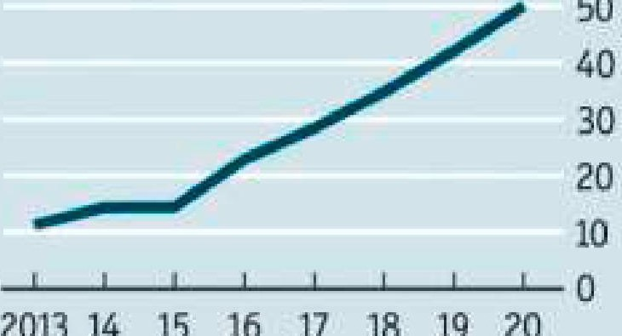

50

2013

14

15

16

-17

18

19

20

### Il. Vocabulary Focus

l. Look at several definitions (1—7) of the 10T below. Work out the meaning of the words in bold. Then answer the following questions.

1. What do all these definitions have in common?
2. Which one is the closest to the option that you offered?
3. Which definition is the most comprehensive? Why?
4. The Internet of Things, commonly abbreviated as IOT, is a computing concept that describes the idea of diverse everyday physical objects being connected to the Internet and being able to discern each other.
5. The 10T refers to the enormous network of devices and physical objects ("things") that can connect to the Internet, recognise other devices and objects, and securely communicate with them.
6. The 10T describes a world where just about anything can be connected and communicate in an intelligent fashion due to embedded chips.
7. The 10T is a system of interrelated computing devices, mechanical and digital machines, objects, animals or people that are provided with unique identifiers (UIDs) and the ability to transfer valuable data over a network without requiring human-to-human or human-to-computer synergy.
8. The 10T is the network of devices such as vehicles and home appliances that apply electronics, software, sophisticated sensors, actuators, and connectivity which allows these things to connect, interact and exchange data and use analytics.
9. The 10T refers to the connection of devices (other than typical ware such as computers and smartphones) to the Internet that can change the way we get energy or purchase goods.
10. The 10T refers to the billions of tangible devices around the world that are now connected to the Internet, collecting and sharing data.
11. Match the words in the box with the synonyms from the words in bold in Task l.

utilise; obtain; safely; interaction; detectors; various; physical; drivers; devices; anal sis; intelligent; huge; built into; smart; identif

1. Watch the video "How It Works: The Internet of Things" [36] and find out what elements the 10T includes and where it can be implemented effectively. Choose the options in the table that are mentioned.

|  |  |  |
| --- | --- | --- |
| 10T Elements |  | 10TA lications |
| medicine education shopping transportation sport entertainment business fashion smart home energy production industry | sensors devices apps nodes | the Web chips cloud storage platform controllers analytics gateway database |

1. Watch the first part of the video (from 0:01 till 1:01) again and complete the gaps with the missing words.

How exactly do all these devices 1)such large quantities of data and how do we put that information to work?

Whether we're 2)the production of a factory, giving city residents realtime 3)on where to park or monitoring our personal health it's the common



Internet of Things 4)  that brings us diverse information together and 5) the common language for the devices and 6) to communicate with each other.

The process starts with the 7)  themselves which securely communicate with an Internet of Things platform. This platform 8)the data from many devices and 9)  analytics to share the most valuable data with applications that address industry specific 10)

1. Watch the rest ofthe video (from 1:02 till the end) again and match each element of the 10T ecosystem on the left with the function it performs.

|  |  |
| --- | --- |
| l. Sensors   1. Gateway 2. Platform 3. Database 4. A lications | 1. is built with a historical record on a network server 2. monitor particular characteristics communicating with each other 3. gathers and stores information 4. solve specific issues e inte rates and sorts the data from the sensors |

1. Read a passage about the IOT. Complete the gaps with the words in the box. There are synonyms in brackets to help you.

multilateral; en ender; notable; vi ilance; stem; holistic; ervade; im lications

As 10T devices start to 1)(prevail) on the market today some related problems may 2)(derive) from this. They can 3)(cause) rather serious 4)(consequences) when 5)(international) measures are required. Eventually, 6)(integrated) approach on the one hand, and every person's 7) (watchfulness) on the other is the only way to get 8)(significant) results.



1. The diagram illustrates how the 10T works. Describe it. Use the target vocabulary from this section.

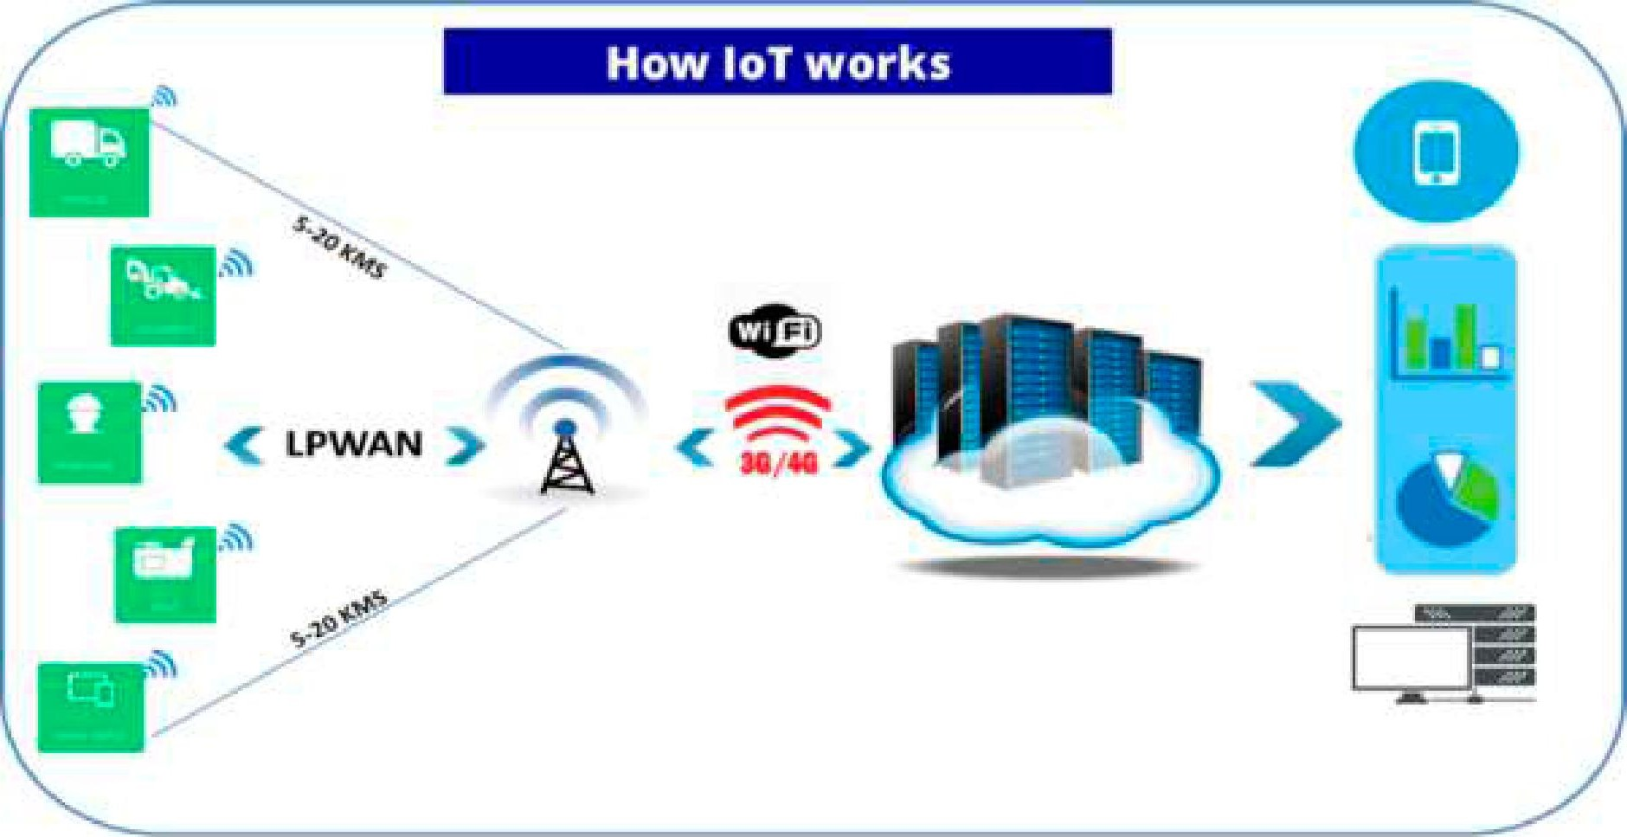

1. Address the table and addfacts with regard to the IOT. Work in groups of three or four people. Report your ideas to the rest of the group.

|  |  |  |
| --- | --- | --- |
| 10T Ecos stem | IoTA | lications |
|  |  |  |

### Ill. Language Box

l. Read the title "Reasonable Approach to IOT" andpredict what the article will be about.

1. Work out the meanings oflhe words in boldfrom the context given.
   1. The system should feature mechanisms and tools for regular internal performance assessment.
   2. Such transactions can occur only between two connected devices.
   3. The effective implementation of new software was the solution to the problem.
   4. Can you spot the difference between these two devices?
   5. The best way would be to flash the BIOS and swap out the cooked CPU.
   6. E-government policies can facilitate access to information infrastructure by promoting connectivity and networking.
2. Skim the article "A Reasonable Approach to the IOT" andfind the paragraphs (A G) where the following questions (1 7) are answered.
   1. How big is the 10T?
   2. Does the 10T have any development perspective?
   3. What elements does the 10T ecosystem include?
   4. What are the benefits of the 10T for consumers?
   5. What device is regarded as an 10T one?
   6. What are the benefits of the 10T for business?
   7. What is the 10T?

## A Reasonable Approach to the 10T

1. Simply put, the Intemet of Things (IOT) is the concept of basically connecting any device featuring an on/off switch to the Internet (and/or to each other). This includes everything from mobile phones, coffee makers, washing machines, headphones, lamps, wearable devices and Wearable device the almost anything else. This also applies to components device that can be worn, of machines, for example a jet engine of an airplane. The such as clothing or glasses 10T is a giant network of connected 'things".
2. The 10T refers to the ever-growing network of physical objects that feature an IP address for Internet connectivity, and the communication that occurs between these objects and other Internet-enabled devices and systems. In simple words, the 10T is an ecosystem of connected physical objects that are accessible through the Internet. All the components that enable businesses, governments, and consumers to connect to their 10T devices, including remotes, dashboards, networks, gateways, analytics, data storage, and security are parts of this ecosystem.
3. Any stand-alone Internet-connected device that can be monitored and/or controlled from a remote location is considered to be an 10T device. With smaller, more powerful chips, virtually all products can be 10T devices covering almost every sphere of our life.

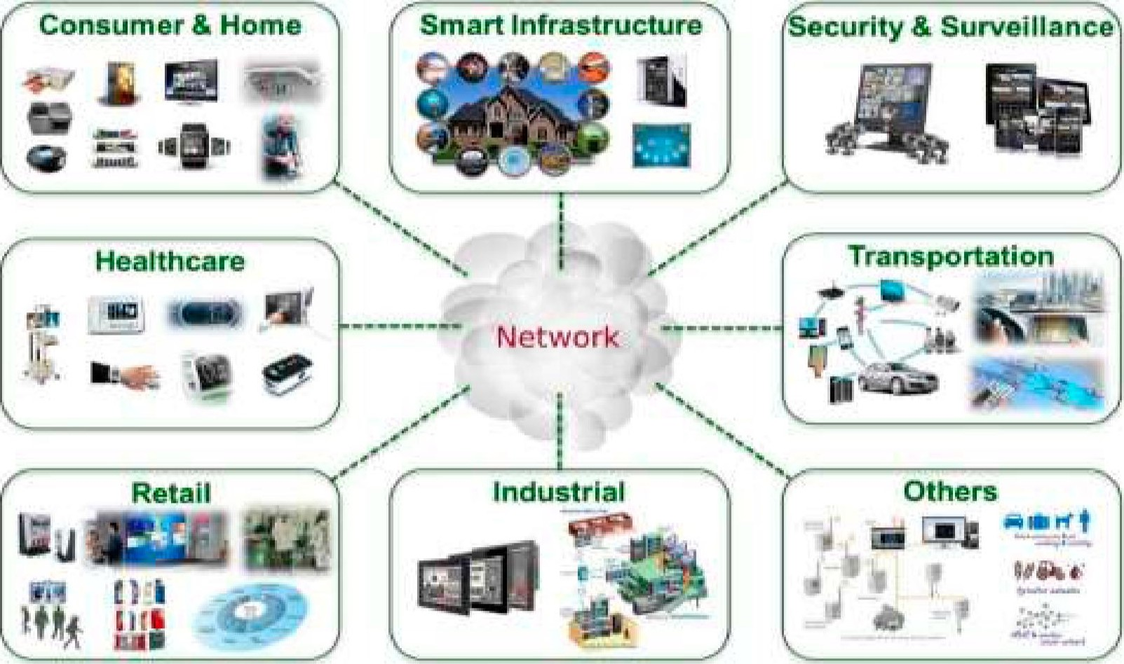

1. The 10T is big and getting bigger. There are already more connected things than people in the world. Experts calculate that more than 23 billion 10T devices were in use in 2018, up 35 percent from 2015, and this will likely reach 75 billion by 2025. Out of those 43 billion devices, more than halfare consumer products like smart TVs and smart speakers.
2. Occasionally known as the Industrial IOT, the benefits of the 10T for business depend on the particular implementation, but the key is that enterprises should have access to more data about their own products and their own internal systems, and a greater ability to make changes as a result. Manufacturers are adding sensors to the components of their products so that they can transmit back data about how they are performing. This can help companies spot when a component is likely to fail and to swap it out before it causes damage. Companies can also use the data generated by these sensors to make their systems and their supply chains more efficient, because they will have much more accurate data about what's really going on.
3. The 10T also promises to make our environment — our homes and vehicles smarter, more measurable, and chattier. Already today smart speakers like Amazon's Echo and Google Home facilitate playing music, setting timers, or getting information. Home security systems make it easier to monitor what's going on inside and outside. Smart car parking systems help you find a parking lot much quicker. Meanwhile, smart thermostats can help us heat our homes before we arrive back, and smart lightbulbs can make it look like we're home even when we're out.
4. Looking beyond the home, in future, autonomous cars and smart cities could change how we build and manage our public spaces. Sensors can help us understand how noisy or polluted our environment is. Health control devices will be able to monitor person's state 24 hours a day collecting, storing and analysing data to be ready to alert about a coming heart attack or stroke. The most used enterprise 10T devices will be smart electric meters and security cameras.
5. Complete the ideas. Address the article in Task 3 ifnecessary.
   1. The 10T refers to
   2. The Internet of Things includes .
   3. The 10T is an ecosystem of .
   4. An 10T device is .
   5. Enterprises benefit from using the 10T when
   6. The leading domestic applications of the 10T today are .
   7. Our future belongs to
6. While the idea of the 10T has been in existence for a long time, a collection of recent advances in a number oftechnologies has made itpractical. Consider what technologies have made the 10T possible and which of them are the most essential. To expand your ideas, match each technology on the left with the explanation. Work with a groupmate.

|  |  |
| --- | --- |
| 1. Access to lowcost, low-power sensor technology 2. Connectivity 3. Cloud computing platforms 3. Machine learning and analytics 4. Conversational Al | 1. The increase in the availability of these platforms enables both businesses and consumers to access the infrastructure they need to scale up without actually having to manage it all. 2. Affordable and reliable detectors are making the 10T technology possible for more manufacturers. 3. Advances in neural networks have brought natural-language processing (NLP) to 10T devices (e.g. personal digital assistants Alexa, and Siri) and made them appealing, affordable, and viable for home use. 4. With advances in these technologies, along with access to vast amounts of data stored, businesses can gather insights faster and more easily. These allied technologies continue to push the boundaries ofthe IOT, and the data produced by the 10T also feeds these technologies. 5. A host of network protocols for the Internet has made it easy to connect sensors to the cloud and to other "things" for efficient data transfer |

1. Consider the ideas below and anticipate thefuture ofthe IoT. Work in groups oflwo or three people.

|  |  |  |  |
| --- | --- | --- | --- |
| |  | | --- | | The 10T will continue to form the backbone of many technologies that will change the way we all live | | |  | | --- | | The potential of the 10T is not just in enabling billions of devices simultaneously but leveraging the huge volumes of actionable data which can automate diverse business processes | |
| |  | | --- | | As networks and 10T platforms evolve to overcome these challenges, through increased capacity and Al, service providers will edge furthermore into IT and Web scale markets — opening entire new streams of revenue | | |  | | --- | | Advances to the industrial Internet will be accelerated through increased network agility, integrated artificial intelligence (Al) and the capacity to deploy, automate, orchestrate and secure diverse use cases at hyperscale | |

IV. Decision Bank

l. Skim the article "The 10T Implementation Challenges and Solutions " below and identify what parts of[he article the ideas refer 10.

l. It could be years before the market settles enough to crown a single universal standard for home IOT.

1. For consumers to make use of the Internet and all that the 10T has to offer, it is essential to work upon their awareness of the changes taking place within the 10T to make it more efficient.
2. With such strong competition in the 10T market, customers whose expectations aren't met won't hesitate to go elsewhere.
3. In cybersecurity terms, 10T devices greatly expand the "attack surface" or the amount of potential areas for cybercriminals to penetrate a secure network.
4. Quality control in the 10T can be tricky from a regulatory perspective.

## The 10T Implementation Challenges and Solutions

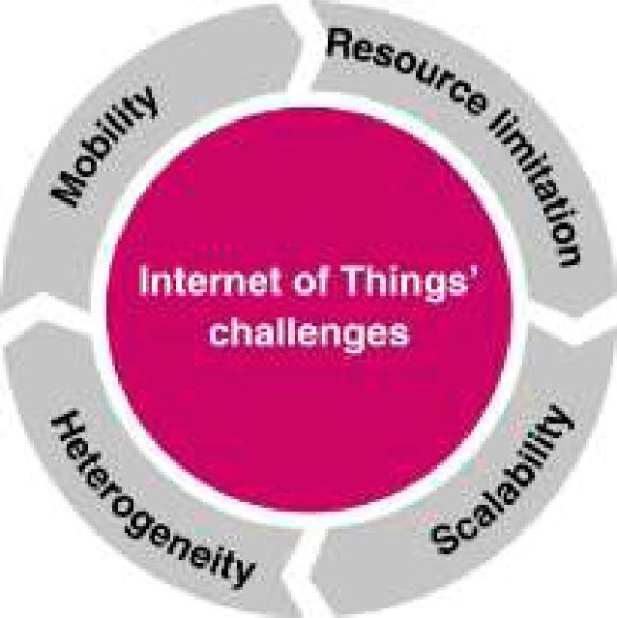In a few short years, the Internet of Things (IOT) has gone from the technologies that were cutting edge to the situation today where connected household items or automobiles are common. And its growth is only really gathering speed now and can comprise as many as 75 billion connected devices by 2025. In fact, according to the researchers and experts, in the future, devices without 10T capabilities may be more expensive because they'll lack data that can be harvested by manufacturers.

That data, though, comes with risks, along with a number of other notable 10T risks and problems that stem directly from this that enterprises will have to overcome in the coming years. If the 10T has a problem, or is exposed to weaknesses, then the users that are connected to it are equally threatened. And here are five major problems connected with the IOT.

Cloud attacks. First of all, since a large amount of data running the 10T will be stored in the cloud, it is likely that cloud providers will be one of the principle targets in this kind of war. While there is growing awareness of this problem, cybersecurity is still under-resourced in comparison to the potential scale of the threat. To get some kind of idea of the problem, the World Economic Forum report cites the analysis suggesting that the takedown of a single cloud provider could cause $50 billion to $120 billion of economic damage — a loss somewhere between Hurricanes Sandy and Katrina.

Lack of regulation about IOT. Another problem is that government regulation often takes a long time to catch up with the current state of technology. With the rapid evolution that's happening every day in the IOT, the government is taking its time in providing standards and regulations and businesses are often left without crucial information they need to make decisions.

Limited Al. The experts also point out that most of the current Al offerings on the market have substantial limits. After all, the machine learning and big data-based Al that currently pervade are powerful tools for identifying associations in large quantities of data, but don't have much on humans in terms of working out the complex phenomena of cause and effect or to identify modifiable factors that can engender desired outcomes.

Challenges with compatibility. Moreover, the researchers have found that home mesh networks are one area where compatibility trouble is looming. Bluetooth has long been the compatibility standard for 10T devices. In fact, it was named after an ancient king, Harald Bluetooth, known for unifying warring tribes. But when it comes to home automation using mesh networking, several competitors have sprung up to challenge Bluetooth's mesh network offerings, including protocols such as Zigbee and Z-Wave.

Understanding IOT. Finally, in 2018, the real issue was how to increase the ability for people to understand the changes and their implications more clearly, and to take concrete actions to take advantage of the potential upside. The 10T is moving into its adolescence as connected devices become smarter and more immersive. Algorithms and data visualisation templates have evolved greatly. All these changes arise the need to provide the public with up-to-date 10T literacy to increase people's flexibility to adopt to fast changing reality.

In fact, while security is undoubtedly one of the major concerns impacting the development of the 10T today, businesses and consumers agree that there should be strong 10T security regulation which will lead to the solution of many other related problems. As it is a multilateral issue it requires a comprehensive, holistic approach. The Internet of Things Security Foundation (IoTSF) is a non-profit body founded by a group of technology companies that will be responsible for vetting connected devices for vulnerabilities and flaws and will offer security assistance to technology providers, system adopters, and end users. But, on the other hand, the latter should remember that vigilance is a key if you want your data to stay yours. You shouldn't simply believe all marketing talks. And it is wise to check reviews of the 10T product and if the manufacturer has a decent track record in advance. l

1. Here are some quoles made by [he experls in [he lol . Guess which problem from [he Oil'licle in TCISk I eclCh oflhem ciddresses. Which one ones are you recidy 10 supporl? Why?

l. "The sad thing about Al is that it lacks artifice and therefore intelligence.'

* 1. "The pace of change has exceeded the rate of human capability to absorb. '
  2. "Some might welcome a move towards a less hyper-globalised online world, but many would not, resistance would be likely, as would the rapid growth of illegal workarounds. '
  3. "The flood of information that swamps us daily produces more pain than gain. '
  4. "Users need different apps for different devices, and it becomes overwhelming, causing mental overload.'

1. Share your opinion on the questions with a groupmate.
   1. Which problem does the author of the article in Task 1 consider the most serious? Why?
   2. Do you agree with the author?
   3. What other challenges concerning the issue can you think of?
   4. What are the solutions to the 10T problems?
   5. What is the future of the IOT?
2. Study the following home applications of the IOT. Consider their benefits, possible problems related to them, and how they can be solved. Which one would you like to obtain? Report to the group. Justify your choice.

|  |
| --- |
| Hiku Shopping Button  This device lets consumers use it in the home as a quick way to manage shared grocery lists. In addition to scanning barcodes, this gadget can also accept voice commands and even place grocery delivery orders to save you a trip to the store. Hiku is much more than a chunky fridge magnet. As you scan or tell it which groceries you need, it can integrate with a number of third-party shopping lists. Planned updates will add online price comparisons and online ordering. Price: $49 |
| AeroGarden Harvest Elite  This smart device allows you to do just that. Driven by low energy and high-powered LEDs, aquaponic pods will soon substitute ordinary plant soil pots.  It can grow up to 6 plants in soilless pods. You will receive reminders to add water and nutrients.  Most plants germinate within 7—14 days and are ready for harvesting in 46 weeks. You can use non-GMO seeds.  And it consumes only 8W of power.  Price: $139.95 |
| Hapifork  This device uses data and immediate feedback to help us be more mindful of what we're eating and drinking. One of the best and simplest ways to lose weight — while still enjoying your food is to eat a little bit slower. Using a capacitive sensor and a built-in vibration motor, Hapifork ("happy fork") will send out gentle physical notifications or flash small indicator lights when it detects that you're shoveling food in faster than you can digest.  Price: $60 |
| Echo  It's an advanced home assistant. It produces rich, detailed sound that automatically adapts to any room. You can stream songs from Amazon Music, Apple Music, Spotify, SiriusXM, and more. It has a built-in hub to voice control compatible lights, locks, and sensors in your home. It sets timers, reminders, and alarms. Alexa answers questions like "Alexa, what time is it?" It can connect to other hands-free devices.  It is built with multiple layers of privacy controls including a mic off button. Price: $49.99 |

### V. Conclusion Worksheet

Consider the following key points and get ready to speak about the 10T in the areas presented below. Work in teams.

 applications tech solutions v/ challenges v/ perspectives

|  |  |  |
| --- | --- | --- |
| Industry |  | Healthcare |
| Transportation |  | Agriculture |

### VI. Web Search

Explore the resources in the list to obtain additional information on the IoT, including topical 10T applications. Report yourfindings in writing.



https://www.iotworldtoday.com/ https://www.itransition.com/blog/ https://builtin.com/internetsubject/iiot iot-history things/iot-examples

Ml. Revision Point

l. Choose the odd one out in the word lines.

1. various diverse ubiquitous miscellaneous
2. recognise discern identify understand
3. varied integrated embedded fixed into
4. driver ware actuator tangible
5. allot apply utilise implement
6. Complete [he senlences with [he words from Task l.
   1. Such is used by the majority of IT companies today.



* 1. Due to security concerns, most enterprises have to extra resources to



defence schemes.

* 1. Devices can't each other without specific fixed into chips.



* 1. Issues surrounding the 10T are and complicated.



* 1. Firefox can now adjust images with colour profiles.



1. Read the article "How Will the Future 10T Industry Look Like? " published on the 101 Blockchains and get ready to render it orally. Record your speech and send it to your groupmate for assessment according to the checklist below. Your overall mark will be provided at the end of the table.

How Will the Future 10T Industry Look Like?

Written by Georgia Weston

Mar 8, 2023

The rapid growth in the 10T industry, with a gradual rise in the number of 10T devices by 2030, is a favorable indicator for the industry. However, it is also important to learn about the implications ofIoT in the future. The following trends could provide an effective answer for understanding the prospects for future of IOT.

### Circular Economy and 10T

10T companies have opened up avenues for minimising waste and improving personal autonomy alongside energy efficiency. However, 10T projects can be sustainable only if it has access to rich sources of data. The responsiveness of 10T networks and their actions would depend on the network's efTectiveness in data connectivity. The recommended actions for achieving a responsive and highperformance 10T system focus on increasing use of 10T devices alongside extension in the use cycle through predictive maintenance.

Networks and 10T

The highlights of predictions for future of 10T would also include the plans for adoption of 5G networks. 5G broadband cellular networks could offer support for higher data transfer rates with considerably minimal latency. The arrival of 5G could increase the number of IoT-connected devices by 2030 as it can power real-time network performance requirements for 10T applications. At the same time, low-latency benefits of 5G networks can improve connectivity and performance of 10T networks.

### Empowering 10T with Artificial Intelligence

The next prominent expectation in the future of 10T would point to possibilities for a combination of Al and IOT. Artificial intelligence is one ofthe prominent strategic technology trends and has significant implications for transforming IOT. Artificial intelligence and 10T complement each other and help in accessing highly valuable insights. Artificial intelligence can help in extracting viable insights from the massive volume of data generated by 10T devices.

Giving Users What They Want

The 10T forecasts for 2030 would also emphasise the necessity for introducing user-centric functionalities in 10T platforms. Spending on 10T solutions would continue growing. However, the major share of 10T spending would go towards 10T software development.

The number of companies dealing with 10T devices would need effective methods for managing the software associated with different devices. Therefore, developers could look up to containerised applications as a solution for the future of 10T software ecosystem. Containers could help 10T companies introduce beneficial functionalities for improving user experiences.

### Foundations ofIndustry 4.0

The domain of technology is in the most dynamic phase right now, with many innovative developments ranging from blockchain to machine learning. Internet of Things can serve as one of the prominent entries among revolutionary technologies which can transform manufacturing and industrial applications.

The IoT-connected devices forecast estimates point out how 10T would become a mandatory requirement for data collection and improvement of operational efficiency. Industries believe that 10T is the most important component of Industry 4.0, alongside big data analytics, cloud infrastructure and Al.

### Strengthening the 10T Security Landscape

The adoption of 10T would increase the amount of user data at risk of unprecedented vulnerabilities. According to Palo Alto Networks, around 57 % of 10T devices are vulnerable to malicious attacks. In addition, the findings of Palo Alto Networks also suggest that 83 % of medical 10T devices use unsupported operating systems.

The growth in the number of 10T devices by 2030 calls for integration of blockchain as an important 10T security tool. Blockchain could ofTer the benefits of cryptographic security for 10T data alongside identity management for 10T networks.

### Decentralisation ofthe 10T Landscape

Decentralisation of 10T through blockchain technology not only improves security but also reduces the burden of computing on the IOT network. Decentralisation could ofTer significant advantages for helping 10T platforms in making better decisions with comprehensive data analytics.

|  |  |  |  |
| --- | --- | --- | --- |
| Summary checklist | Yes | Undecided | No |
| 1. The origin of the publication was mentioned |  |  |  |
| 2. The date of the column was provided |  |  |  |
| 3. The style of the script was defined and justified |  |  |  |
| 4. The genre of the post was indicated and justified |  |  |  |
| 5. The author of the article was called |  |  |  |
| 6. The title of the post was given |  |  |  |
| 7. The main idea of the article was identified |  |  |  |
| 8. The important points were included |  |  |  |
| 9. The unnecessary details were left out |  |  |  |
| 10. The personal opinion/impression of the article was given |  |  |  |
| I l. The personal view on the topic/problem was provided |  |  |  |
| 12. The summary included own vocabulary not citations |  |  |  |
| 13. The summary was full of varied grammar structures |  |  |  |
| The overall mark (excellent/good/satisfactory/below average/bad) |  | | |

4. Get ready to speak on the topics below and assess your performance according to the following scale.

|  |  |  |
| --- | --- | --- |
| Comprehensive | Rather confident | Limited |

* Definition and applications of the IOT.
* 10T ecosystem.
* Benefits that the 10T brings.
* Problems related to the 10T and their solutions.
* Future of the IOT.

Wordlist

Topic: Computer Networks

|  |  |
| --- | --- |
| Allot v  Analytics n  Artificial adj  Bandwidth n  Bridge n, v  Broadband adj  Broadcast v, n  Browser n  Cellular adj  Compatible adj  Demodulator n  Dial-up adj  Discern v  Diverse adj  Driver n  Download n, v  Engender v  Enormous adj  Ethernet n  Extend v  Extension n  Fibre-optic adj  Frequency n  Gateway n  Holistic n Host n, v  Hotspot n  Hub n  Hyperlink n, v  Hypertext n  Identifier n  Immersive adj  Implication n  Instant n, adj  Jitter n  Latency n  Link n, v  Medium (mediap/) n  Modem n  Modulator n  Multilateral adj  Narrowband adj  Node n  Notable adj | Packet n  Pervade v  Ping n, v  Range n, v  Recipient n  Repeater n  Router n  Sandboxing n  Satellite n  Securely adv  Sophisticated adj  Spot n, v  Stem n, v  Swap n, v Synergy n  Tag n, v  Terrestrial adj  Upload n, v  Utilise v  Viable adj Vigilance n  Ware n  Wavelength n  Wire n, v  Wired adj  Wireless adj  Collocations:  Client-server network  Cloud computing  Cloud storage  Coaxial cable  Data centre  Domain name  10T ecosystem  Full/Partial mesh  Network topology  Search box  Search engine  Signal interference  Twisted pair Wearable device  Virtual machine |

List of Abbreviations

|  |
| --- |
| ADSL — Asymmetric Digital Subscriber Line  Al — Artificial Intelligence  ALU — Arithmetic Logic Unit  API — Application Programming Interface  AR — Augmented Reality  ATM — Automated teller machine (Cash-point)  BIOS — Basic Input Output System  BSoD — Black screen of death  CPU — Central Processing Unit  CU - Control Unit  DDoS - Distributed denial-of-service  DIMM Dual in-line memory modules  DL — Deep learning  DNS — Domain Name Server DOS — Denial of service dp — dot pitch  DSL — Digital subscriber line  DSS — Decision support system  FTP - File Transfer Protocol  GSM — Global System for Mobile Communication (Groupe Spécial Mobile)  GUI — Graphical User Interface  HDD - Hard Disk Drive  HTML — Hypertext Markup Language  HTTP - Hypertext Transfer Protocol  ICT — Information and Communications Technology/Technologies  ID — Identity document  InfoSec — Information security  10T - Internet of Things  IRC — Internet Relay Chat  IS — Information System  ISP — Internet Service Provider  LAN — Local Area Network  MAN — Metropolitan Area Network  MIS — Management information system  ML — Machine learning  OOP — Object-oriented programming  PAN — Personal Area Network  PC — Personal computer  PDA — Personal digital assistant  PIN — Personal identification number  POP - Post Office Protocol P2P - Peer-to-peer  P2P - Point-to-point  QoS — Quality of service  RAM — Random Access Memory |
| ROM - Read only Memory  RSS — Really Simple Syndication  SDLC — System development life cycle  SDSL — Symmetric Digital Subscriber Line  SMTP - Simple Mail Transfer Protocol  SSD — Solid State Drive  STOP — Security Tracking of Office Property  SU — System Unit  TCP/IP — Transmission Control Protocol/lnternet Protocol  TelNet — Telecommunication Network  TPS — Transaction processing systems  UDP — User Datagram Protocol  UID — Unique identifier  URL — Uniform Resource Locator  USB — Universal Serial Bus  VolP — Voice over Internet Protocol  VR — Virtual Reality  WAN — Wide Area Network  WAP — Wireless access point  Wi-Fi - Wireless Fidelity  WWW World Wide Web  XML - Extensible Marku Lan ua e |

40